Disabilities Policy

Purpose of the Policy
The purpose of this policy is to meet the educational needs of students with disabilities in a manner that complies with relevant anti-discrimination and accreditation legislation, and takes into account student learning needs while balancing the interests of all parties affected

Scope
This policy applies to employees, volunteers, parents/carers and students and outlines the procedures for identifying and enrolling students with disabilities and the process undertaken to develop individual education programs for students so identified.

Definitions
Disability, in relation to a person, means:
- total or partial loss of the person’s bodily or mental functions; or
- total or partial loss of a part of the body; or
- the presence in the body of organisms causing disease or illness; or
- the presence in the body of organisms capable of causing disease or illness; or
- the malfunction, malformation or disfigurement of a part of the person’s body; or
- a disorder or malfunction that results in the person learning differently from a person without the disorder or malfunction; or
- a disorder, illness or disease that affects a person’s thought processes, perception of reality, emotions or judgment or that results in disturbed behaviour; and includes a disability that:
- presently exists; or
- previously existed but no longer exists; or
- may exist in the future (including because of a genetic predisposition to that disability); or
- is imputed to a person.

To avoid doubt, a disability that is otherwise covered by this definition includes behaviour that is a symptom or manifestation of the disability (Disability Discrimination Act 1992, Cth).

Responsibility
Principal

Point of Contact
Deputy Principal Learning and Teaching

Legislation
Anti-Discrimination Act 1991 (Qld)
Australian Human Rights Commission Act 1986 (Cth)
Disability Discrimination Act 1992 (Cth)
Disability Standards for Education 2005 (Cth), including Guidance Notes
Australian Education Act 2013 (Cth)
Education (Accreditation of Non-State Schools) Act 2017 (QLD)
Education (Accreditation of Non-State Schools) Regulation 2017 (QLD)
Related Policies and Documents
Enrolment Terms and Conditions
Anti-Discrimination Policy
Privacy Policy
Anti-Bullying Policy
Code of Conduct
Procedure for Identification and Program Considerations for Students with Particular Learning Needs

Introduction
The Commonwealth Disability Discrimination Act 1992 (DDA) makes discrimination against people on the grounds of disability unlawful in a wide range of areas of public life, including education. Similar provisions also exist in the Queensland Anti-Discrimination Act 1991.
The Queensland Education (Accreditation of Non-State Schools) Act 2001 prescribes ‘the school’s educational program and student welfare processes’ as an accreditation criterion, and makes it mandatory for all schools to have written processes about students with disabilities.

In particular, schools must have written processes for identifying students with disabilities, and for devising an educational program, ‘specific to the educational needs of those students with a disability, that complies with relevant anti-discrimination legislation’.

In addition, schools must comply with the Disability Discrimination Act Education Standards which took effect on 17 March, 2005.

The objects of these Standards are:
(a) to eliminate, as far as possible, discrimination against persons on the ground of disability in the area of education and training; and
(b) to ensure, as far as practicable, that persons with disabilities have the same rights to equality before the law in the area of education and training as the rest of the community; and
(c) to promote recognition and acceptance within the community of the principle that persons with disabilities have the same fundamental rights as the rest of the community.

To comply, an education provider must make ‘reasonable adjustments’ to accommodate a student with a disability. An adjustment is a measure or action taken to assist a student with a disability to participate in education and training on the same basis as other students. An adjustment is reasonable if it does this while taking into account the student’s learning needs and balancing the interests of all parties affected, including those of the student with the disability, the education provider, staff and other students.

A provider is also required to comply in relation to its obligation to put in place strategies and programs to prevent harassment and victimisation. That is, it must ensure that staff and students know not to harass or victimise students with disability, or students who have associates with a disability, and must take reasonable steps to ensure that staff and students know what to do if harassment or victimisation occurs.

Consistent with the DDA, an education provider does not have to comply with a requirement of the Standards to the extent that compliance would cause ‘unjustifiable hardship’. The provider may consider all costs and benefits, both direct and indirect, that are likely to result for the provider, the student and any associates of the student, and any other persons in the learning or wider community, including:

- costs associated with additional staffing, the provision of special resources or modification of the curriculum
- costs resulting from the student’s participation in the learning environment, including any adverse impact on learning and social outcomes for the student, other students and teachers, and
- benefits deriving from the student’s participation in the learning environment, including positive learning and social outcomes for the student, other students and teachers, and any financial incentives, such as subsidies or grants, available to the provider as a result of the student’s participation.

In assessing whether an adjustment to the course or program in which the student is enrolled, or proposes to be enrolled, is reasonable, the provider is entitled to maintain the academic requirements of the course or program, and other requirements or components that are inherent in or essential to its nature.

There is no requirement to make unreasonable adjustments. The concept of unreasonable adjustment is different from the concept of unjustifiable hardship on the provider. In determining whether an adjustment is reasonable the school may consider any effect of the proposed adjustment on anyone else affected, including the education provider, staff and other students, and the costs and benefits of making the adjustment. The specific concept of unjustifiable hardship is not considered. It is only when it has been determined that the adjustment is reasonable that it is necessary to go on and consider, if relevant, whether this would nonetheless impose the specific concept of unjustifiable hardship on the provider.

Policy Statement
Bethania Lutheran School values the diversity of all students including those with special educational needs; recognises the right of all students to equitable access to the curriculum, and offers education programs specific to the educational needs of students with disabilities.

Responsibilities

School Responsibilities
Bethania Lutheran School will not unlawfully discriminate, harass or victimise a student on the ground of the student’s disability or a disability of any associate of a student. The school acknowledges that its responsibilities are as follows:
- Enrolment – Bethania Lutheran School will take reasonable steps to ensure that a student with a disability is able to seek admission to, or apply for enrolment in, the school on the same basis as a prospective student without a disability, and without experiencing discrimination.
- Participation – Bethania Lutheran School will take reasonable steps to ensure that a student with a disability is able to participate in the courses or programs provided by the school, and use the facilities and services provided by it, on the same basis as a student without a disability, and without experiencing discrimination.
- Curriculum development, accreditation and delivery – Bethania Lutheran School will take reasonable steps to ensure that courses and programs are designed in such a way that a student with a disability is able to participate in the learning experiences (including the assessment and certification requirements) of the course and program on the same basis a student without a disability, and without experiencing discrimination.
- Support services – Bethania Lutheran School will take reasonable steps to ensure that a student with a disability is able to use support services used by other students of the school in general on the same basis as a student without a disability, and without experiencing discrimination.
- Harassment and victimisation – Bethania Lutheran School will develop and implement strategies and programs to prevent harassment or victimisation of a student with a disability, or a student who has an associate with a disability, in relation to the disability.
Reasonable steps will depend upon the specific circumstances at the time, but may include reasonable adjustments that do not impose an unjustifiable hardship.
When considering an adjustment for a student with a disability, any confidential information provided to Bethania Lutheran School will not be disclosed except for the purposes of the adjustment or in accordance with a lawful requirement, in compliance with the Bethania Lutheran School Privacy Policy.
All students and employees at Bethania Lutheran School have a responsibility not to engage in discriminatory conduct, including harassment and victimisation, and to uphold the school’s policies on these issues.
If students, parents or employees believe that this type of behaviour is occurring in the school, they are able to make a complaint under the Bethania Lutheran School Grievance Procedures.

Implementation
Implementing the Policy
Bethania Lutheran School will assist the full participation of students with disabilities by:

- valuing all students as individuals and identifying and responding to their needs;
- consulting with the student and parents to make well-informed decisions about the education program to be developed for each student with a disability/ies;
- identifying and addressing barriers that limit students' opportunities, participation and benefits from schooling;
- providing an appropriate level of resources within available funds in order to reasonably accommodate the needs of students with disabilities;
- making reasonable adjustments in modifying, substituting or supplementing curricula, course work requirements, timetables, teaching methods and materials, and assessment procedures to meet the needs of students with disabilities;
- facilitating options and pathways for students with disabilities;
- providing physical environments that are accessible, stimulating, safe and welcoming;
- devising fair and transparent enrolment procedures for all students, including those with disabilities;
- respecting the rights of people with disabilities to privacy and confidentiality;
- fostering and encouraging among staff and students, positive, informed and unprejudiced attitudes towards people with disabilities; and
- supporting and assisting students to make alternative satisfactory educational arrangements when the school is unable to meet their needs.

Enrolment
The Bethania Lutheran School Enrolment Policy is inclusive of all students. The criteria for enrolment are clearly set out in the application for enrolment form, including how decisions are made with regard to priority in the enrolment process. Where the number of places available is limited, priority is decided as follows:

(a) siblings (of existing students) and children of former students;
(b) active communicant members of the Bethania Lutheran Community Church;
(c) active members of other Christian denominations;
(d) students returning from an approved leave of absence;
(e) capacity to resource identified additional learning and/or support needs – where a
student has been identified as having additional needs, an assessment of the
students’ needs may be undertaken by the school or an independent body; and
(f) date of receipt of application.
It is important to us that we, as a school, can meet the educational needs of each child. For this reason, all parents are required to complete the questions attached to the school enrolment form which facilitate the enrolment process and enable us to determine the resources required to meet each individual student’s needs.

If a child has special education needs, parents/caregivers are asked to sign a permission form which allows the school to collect information from specialist personnel who may have information to assist in meeting the needs of their child. Specialist personnel may include the child’s previous school, disability agencies, medical and allied health professionals.

The collection, use and disclosure of information about a child is protected by the provisions of the School’s Privacy Policy, a copy of which can be obtained from our website or from school reception

Identification
The level of specialist educational support required by students with disabilities is identified through the Procedure for Identification and Program Considerations for Students with Particular Learning Needs. This includes the collection of information from parents or caregivers at interview, possibly completion of a parent-student questionnaire and consultation with specialist personnel, including the School’s learning support teacher.

The collation of this information will help ascertain the student’s need for:
- Physical access- equipment, building modification
- Personal care
- Health care management – medication, emergency procedures
- Communication
- Specific teaching strategies.

Based on the information gathered, the Principal or delegated staff member will make a preliminary assessment of the student’s curriculum support needs, and the school’s ability to meet these needs.

At this time the Principal, or delegated staff member, will meet with parents/caregivers to discuss the outcomes of the information-gathering process and to present the educational program the School can offer. This discussion may involve:

- the student, if appropriate
- special education advisers from Independent Schools Queensland
- agency representatives
- therapists, counsellors, other professionals
- an advocate
- an interpreter.

It is possible at this time that the enrolment will not proceed because parents form the view that the school cannot meet their child’s needs, or the school can demonstrate that the enrolment will cause unjustifiable hardship.

Education Program
Parents will receive in writing an outline of the support the school can offer the student in order for them to access the curriculum successfully.

The Student Support Plan will include such matters as:
A: the basis for the comprehensive collection of the information about the needs of students with disabilities. A list of the information collected and the significance of the information to the formation of the Support Plan.

B: the documentation of curriculum/assessment modifications and issues related to behaviour management, liaison with parents and outside agencies, as appropriate. It will outline resource requirements, including facilities and equipment, evacuation and emergency procedures, reporting requirements, and training requirements for staff or others who work with the student.

C: the development of Health Care Plans for students with health support needs.
The Student Support Plan will be reviewed annually or when necessary and at this time parents will be requested to meet with the Principal, or delegated representative, in order to discuss the progress of their child.

FLOW CHART
(Taken from: Students with Disabilities: Enrolment Guidelines for Independent Schools, SA Independent Schools Targeted Programs Authority Inc., Adelaide: Hyde Park Press)

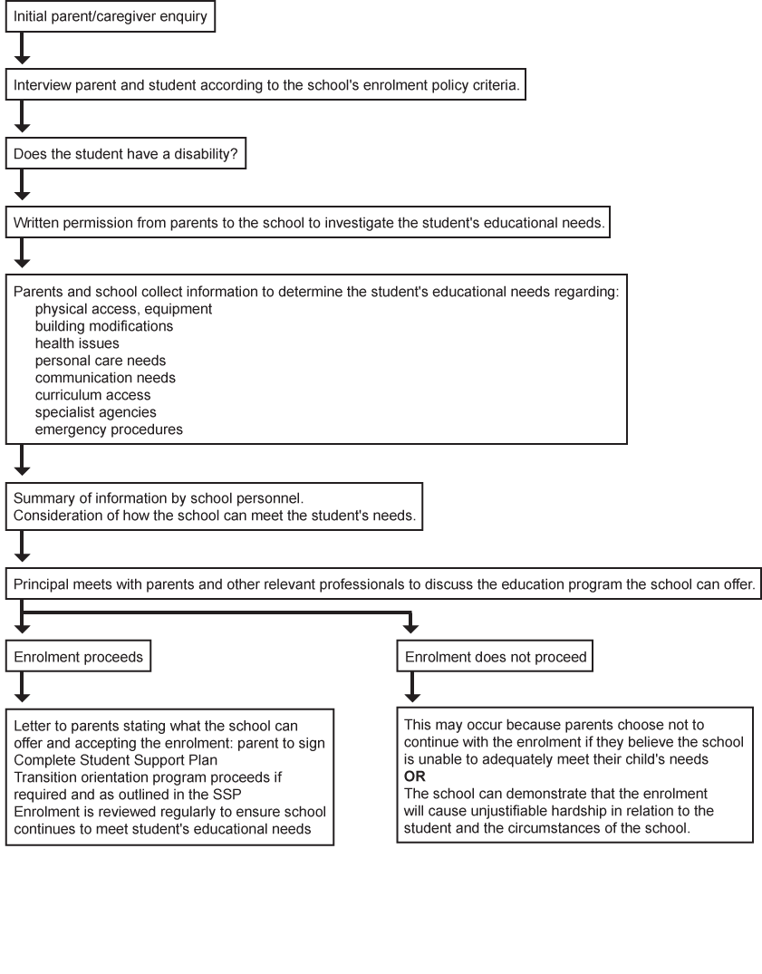
Policy Release Details
Date of Policy December 2021
Review Bi-Annually

1 It is unlawful for an educational authority to discriminate against a person on the ground of the person’s disability: (a) by refusing or failing to accept the person’s application for admission as a student; or (b) in the terms or conditions on which it is prepared to admit the person as a student. It is unlawful for an educational authority to discriminate against a student on the ground of the student’s disability: (a) by denying the student access, or limiting the student’s access, to any benefit provided by the educational authority; or (b) by expelling the student; or (c) by subjecting the student to any other detriment It is unlawful for an education provider to discriminate against a person on the ground of the person’s disability: (a) by developing curricula or training courses having a content that will either exclude the person from participation, or subject the person to any other detriment; or (b) by accrediting curricula or training courses having such a content. (3) This section does not render it unlawful to discriminate against a person on the ground of the person’s disability in respect of admission to an educational institution established wholly or primarily for students who have a particular disability where the person does not have that particular disability.
2 Measures that the education provider may implement to enable the prospective student to seek admission to, or apply for enrolment in, the institution on the same basis as a prospective student without a disability include measures ensuring that: - information about the enrolment process addresses the needs of students with disabilities; and is accessible to the student and his or her associates; and; is made available in a range of formats depending on the resources and purposes of the provider and within a reasonable timeframe; and - enrolment procedures are designed so that the student, or an associate of the student, can complete them without undue difficulty; and - information about entry requirements, the choice of courses or programs, progression through those courses or programs and the educational settings for those courses or programs is accessible to the student and his or her associates in a way that enables the student, or associates, to make informed choices.

