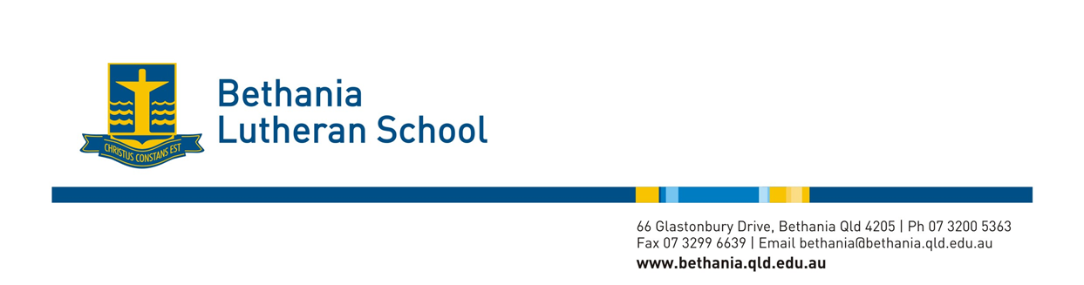
2018 Chapel plan
2018 Theme verse: “The earth and everything on it belong to the LORD. The world and its people belong to him.” (Psalm 24:1)
Term 1- Cosmic Sanctuary: Earth is a Site for Celebration
Week | Notes | Bible passage/Topic | Class Roster
1 |  | No Chapel – Australia Day | Teachers
2 |  | God Created the World - The Beginning  Genesis 1:1-24 | Year 5
3 | Student Leader Installation | Celebrations - Community  Praise - Psalm 95:1-7 | Year 6
4 | Lent Ash Wednesday | Celebrations - Australia  Praise - Psalm 136:1-9 | 4TM
5 | Preps 1st Chapel  Year 6 Sing - This Little Light of Mine | Celebrations - World  Praise - Psalm 148 | YEAR 2
6 |  | Easter – Lent, Palm Sunday | 4BV
7 |  | Easter – Last supper | 3DW
8 |  | Easter – Death | Year 5
9 | X Country Carnival | Easter – Resurrection, New Life | 3EJ
10 | Easter | No Chapel – Good Friday | NA

Chapel Term 2- Earth is a Book of Nature: “Planet earth is a book of nature in the library called creation, a rare volume filled with science, stories and stunning images.”
Week | Notes | Bible passage/Topic | Class Roster
1 | World Earth Day | Celebration of the Earth - World Earth Day | Year 6
2 |  | Celebration of Diversity  Human beings are a special creation of God  Human beings are created ‘in the image of God’ | 5JR
3 | Year 4 Camp | God created the world Job 12:7-10  No matter what books we have or access, the reality is we all have access to the book of nature. | Year 1
4 |  | The wonder of water sea, ocean John 7:38, Job 37: 6-7 | 5SB
5 | NAPLAN / Pentecost | Pentecost Story Acts 2:17-21 | Year 6
6 |  | The wonder of earth (land) plants, trees Psalm 104:14 | 3DW
7 |  | The wonder of sun, moon and stars (Investigate Louie Giglio)  Psalm 19:1-4 | Year 1
8 |  | The wonder of water animals and birds Psalm 104:24-25  Possible Stories: Rainbow fish /  Jesus feeds 5000- Matthew 14:13-21, | 3EJ
9 | Athletics Carnival | The wonder of Land Animals  Genesis 1:24 | 2PW
10 | Year 5 Camp | The wonder of the Human Body Psalm 139:13-16 | 2AH
Chapel Term 3- Earth is a Wounded Planet
Week | Notes | Bible passage/Topic | Class Roster
1 |  | Genesis 6:9-17- Noah and the flood- Our earth is wounded and even though nature can destroy the planet, God continues to look after it. e.g. Bushfires, flood reinvigorate growth | 1JM
2 |  | Psalm 104:10-18, Psalm 147:8-9, God takes care of the earth  - provides streams, rain, food, soil, earth | 2AH
3 |  | Jeremiah 12:10-11, Joel 1:17-20, Genesis 1:29-30  Exodus 23:10-11, How can we take care of the earth? | 3EJ
4 |  | Luke 12:24-28 God takes care of the animals, God feeds the birds | 1GL
5 |  | Genesis 1:26-28, How can we take care of the animals? Ezekiel 34:2-3 We are commanded by God to take care of the earth and animals | 4TM
6 | Walk for Cambodia? | (Luke 14:13-14) Or Year 5 to choose based on walk focus.  How can we take care of other people?  We have a responsibility to look after all of God’s creatures AND each other | Year 5
7 |  | Psalm 104:25-30 Look after our oceans. | 4BV
8 |  | Proverbs 27:18 We might not be able to tend to the world but we can tend our own little corner of it…..Taking care of the environment in the home and garden. | PTS
9 | Year 6 Camp | Philippians 2:2; Taking care of the environment in the school. | PJL
10 | Junior Sports Carnival | Ephesians 2:10 , Galatians 6:9 - God put us on this planet, under Jesus, to work and help others. God planned for us to do good things. (Summary of the term) | 2PW

Chapel Term 4- Earth is a Caring Mother- Become aware that we are nurtured by planet earth and learn from it how to survive on this fragile planet.
Week | Notes | Bible passage/Topic | Class Roster
1 |  | Psalm 139:13-16 (focus on verse 15).Made from the Earth | 1GL
2 |  | Jeremiah 2:7 Earth Provides our needs | 4TM
3 | Reformation Day (31st Oct) | - Revise the importance of the day 501 years ago.  - Reformation Day Lego YouTube clip. | 4BV
4 | All Saints Day | - What do you do to remember your grandparents/loved ones who have passed away?  - Could also talk about Remembrance Day (11th Nov) | Year 5
5 |  | Don’t Worry! God will look after you Luke 12:6-7, Luke 12:22-34  Matthew 10:29-31 | 3DW
6 | Preparing for Christmas | Joshua 1:9 - Link to the angels reassuring Mary and the shepherds. | 1JM
7 | Christmas | Focus on the gift of Jesus - Birth/Nativity | Kindy
8 | Year 6 final chapel | Year 6/ Prep singing | Yr 6/Prep
9 | No Chapel – Closing service | - | NA

